Maryland APEX Accelerator
5825 University Research Ct. Suite 1300
College Park, MD 20740
301 405 6550
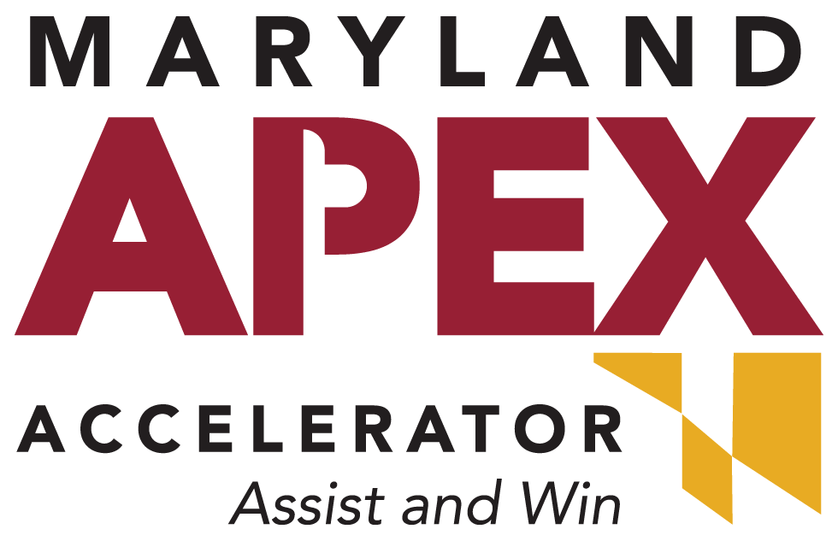

BID MATCH SERVICE FOR MDAPEX CLIENTS ONLY
Complete this form and send it to your APEX counselor and request the payment link. We cannot activate a Bid Match subscription unless you have had at least ONE counseling session.

Maryland APEX Accelerator’s Electronic Bid Matching service will save your company valuable time and money by locating federal, state, local, and foreign bid opportunities and delivering them to you daily by e-mail.

This service is daily, with hundreds of opportunities that are matched against our client profiles.

Some sources are as follows:

- Sam.gov
- DLA small purchases
- Other federal small purchases
- Blue Tops
- State, county, local government
- USA Bid
- International bids

The Maryland APEX Accelerator has purchased the right to provide this Bid Matching Service to our clients at a reduced cost.

Using a detailed profile of your company’s capabilities, built by Maryland APEX counselors, bid matches are delivered to you daily by email.

Complete the Bid Match application below to set up your profile and begin receiving bid opportunities that match your capabilities!

For MDAPEX office use only:

Client # ____________________

The Maryland APEX Accelerator Bid Matching Application
Business Name:
Contact Name:
Title:

(Complete all information contained in this section so we can update our records)
Street Address:
City: State: Zip:
Phone: Fax:
E-mail Address: (Note: All bid matches will be sent to this e-mail address)

Are you interested in bidding on state opportunities? Yes No
If yes, specify which states, or list nationwide for all States:

For federal contract opportunities, please note in which states you can perform:
VA MD DC DE, Please specify any other(s):

*Delivery service is by Email only.
Please check your email regularly, and contact your primary counselor if any changes need to be made to your Bid Matching account. Your Bid Matching profile may need to be changed if you are receiving too many or too few Bid Matching emails. Please let us know if you feel that the matches you are receiving are not appropriate based on what your company offers, and what type of matches you are looking for, so that we can change your Bid Matching profile.

A 6 month subscription is $150. A 12 month subscription is $300.00.

Instructions

- Complete this form, save it, and email it to your counselor. You will receive a payment link via email. Bid match applications will be activated within 10 business days of receipt.

CATEGORY TABLE—SERVICES – Check all that apply  Code Description  __A Research and Development  __B Special Studies and Analyses (not R & D)  __C Architect and Engineering Services  __D Information Technology Services, including Telecommunication Services  __E Purchase of Structures and Facilities  __F Natural Resources and Conservation Services  __G Social Services  __H quality Control, Testing, and Inspection Services  __J Maintenance, Repair, and Rebuilding Equipment  __K Modification Equipment  __L Technical Representative Services  __M Operation of Government-Owned Facility  __N Installation of Equipment  __P Salvage Equipment  __Q Medical Services  __R Professional, Administrative, and Management Support Services  __S Utilities and Housekeeping Services  __T Photographic, Mapping, Printing, and Publication Services  __U Education and Training Services  __V Transportation, Travel, and Relocation Services  __W Lease or Rental Equipment  __X Lease or Rental of Facilities  __Y Construction of Structures and Facilities  __Z Maintenance, Repair or Alteration of Real Property  CATEGORY TABLE—SUPPLIES- Check all that apply  Code Description  __10 Weapons  __11 Nuclear Ordinance  __12 Fire Control Equipment  __13 Ammunition and Explosives  __14 Guided Missiles  __15 Aircraft and Airframe Structural Components  __16 Aircraft and Components and Accessories  __17 Aircraft Launching, Landing, and Ground Handling Equipment  __18 Space Vehicles  __19 Ships, Small Craft, Pontoons, and Floating Docks  __20 Ship and Marine Equipment  __22 Railway Equipment  __23 Ground Effect Vehicles, Motor Vehicles  __24 Tractors  __25 Vehicular Equipment Components  __26 Tires and Tubes  __28 Engines, Turbines, and Components  __29 Engine Accessories  __30 Mechanical Power Transmission Equipment  __31 Bearing  __32 Woodworking Machinery and Equipment  __34 Metalworking Machinery  __35 Service and Trade Equipment  __36 Special Industry Machinery  __37 Agricultural Machinery and Equipment | __ 38 Construction, Mining, Excavating, and Highway Maintenance Equipment  __ 39 Materials Handling Equipment  __40 Rope, Cable, Chain, and Fittings  __41 Refrigeration, Air Conditioning, and Air Circulation Equipment  __42 Fire Fighting, Rescue, and Safety Equipment  __43 Pumps and Compressors  __44 Furnace, Steam Plant, and Drying Equipment  __45 Plumbing, Heating, and Sanitation Equipment  __46 Water Purification and Sewage Treatment Equipment  __47 Pipe, Tubing, Hose, and Fittings  __48 Values  __49 Maintenance and Repair Shop Equipment  __51 Hand Tools  __52 Measuring Tools  __53 Hardware and Abrasives  __54 Prefabricated Structures and Scaffolding  __55 Lumber, Millwork, Plywood, and Veneer  __56 Construction and Building Materials  __58 Communications, Detection, and Coherent Radiation Equipment  __59 Electrical and Electronic Equipment Components  __61 Electric Wire, and Power and Distribution  __62 Lighting Fixtures and Lamps  __63 Alarm, Signal and Security Detection Systems  __65 Medical, Dental, and Veterinary Equipment and Supplies  __66 Instruments and Laboratory Equipment  __67 Photographic  __68 Chemicals and Chemical Product  __69 Training Aides and Devices  __70 ADP Equipment Software, Supplies, and Support Equipment  __71 Furniture  __72 Household and Commercial Furnishing and Appliances  __73 Food Preparation and Serving Equipment  __74 Office Machines  __75 Office Supplies and Devices  __76 Books, Maps, and other Publications  __77 Musical Instruments, Photographs, and Home-type Radios  __78 Recreational and Athletic Equipment  __79 Cleaning Equipment and Supplies  __80 Brushes, Paints, Sealers, and Adhesives  __81 Containers, Packages, and Packing Supplies  __83 Textiles, Leather, Furs, Apparel and Shoes, Tents, Flags  __84 Clothing, Individual Equipment, and Insignia"  __85 Toiletries  __87 Agricultural Supplies  __88 Live Animals  __89 Subsistence (Food)  __91 Fuels, Lubricants, Oils, and Waxes  __93 Nonmetallic Fabricated Materials  __94 Nonmetallic Crude Materials  __95 Metal Bars, Sheets, and Shapes  __96 Ores, Minerals, and Their Primary Products  __99 Miscellaneous

Please list your company’s NAIC / SIC / PSC/FSC (up to 20 each) codes below and specific keywords for your product/service(s):

Please list the states you are interested in doing business and want bid information sent via e-mail:

Bid Matching application checklist. Have you:

Had at least 1 counseling session with the APEX Accelerator?
Completed this Bid Match form?
Listed your company’s NAICS / SIC / PSC/FSC codes and keywords?
Made your payment?

With a full understanding of and agreement to the above, I hereby make an application for active Bid Matching status with the Maryland APEX Accelerator

Please print legibly, sign, and date:

Print Name:_____________________________________

Signature: ______________________________________

Date: __________________________________________

SAVE THIS COMPLETED FORM AND EMAIL IT TO YOUR COUNSELOR.

THANK YOU!

